SYSTEM MANUAL

# ***Minimum hardware***

* Computers: OS X, Linux, Windows

- 1 GHz 32-bit (x86) or 64-bit (x64) CPU

- 1 GB of RAM

- 128 MB of graphics memory

* iOS devices: iPad, iPhone.
* Android devices: tablets, phones.

# ***Software requirements***

* OpenGL ES 2.0
* Android 2.2.
* Python 2.7 - 3.7

# ***Installation guide***

* Installing on Windows:

1. First, create an environment named kivy_venv in your current directory

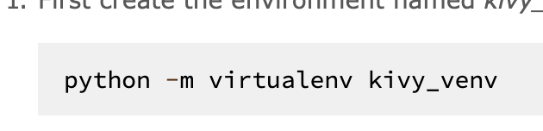

2. Activate the virtual environment. You’ll have to do this step from the current directory every time you start a new terminal. On windows CMD do:



3. Install the dependencies



4. Install Kivy:

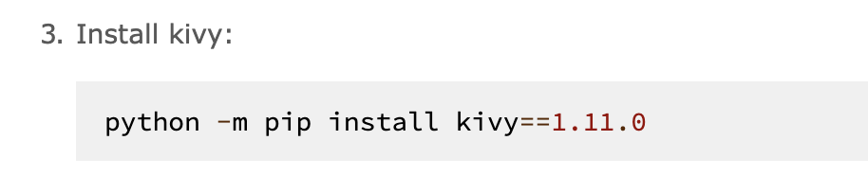

* Installing on OSx and Linux:



# ***Explanations of error messages and troubleshooting guides***

1. Error: You have not given the program input.

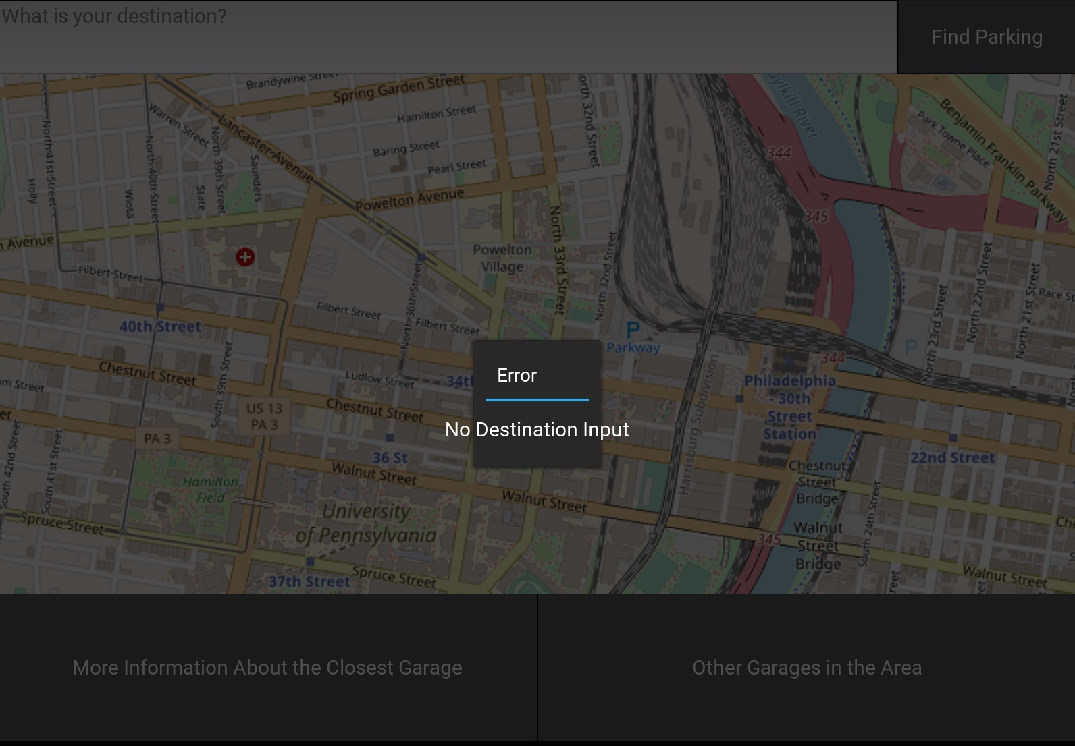

Solution: Give the program input to fix this error.

2. Error: The map does not display on the screen

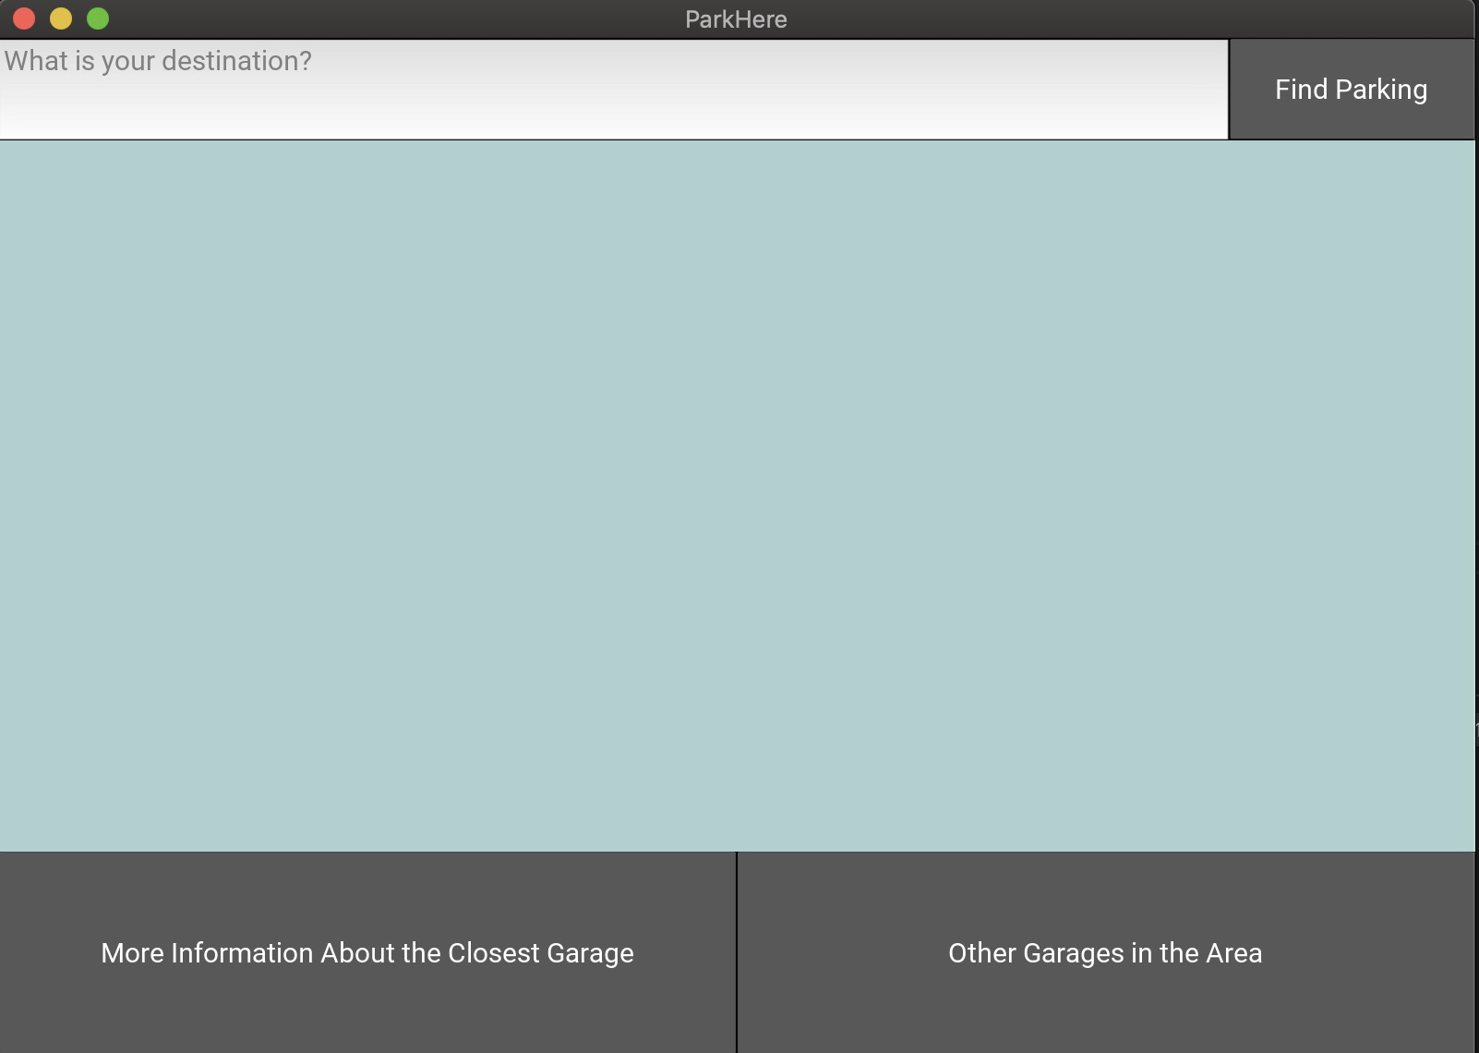

Solution: Download the open street map catalog

3. Error: The program sends to many requests to the map view Database 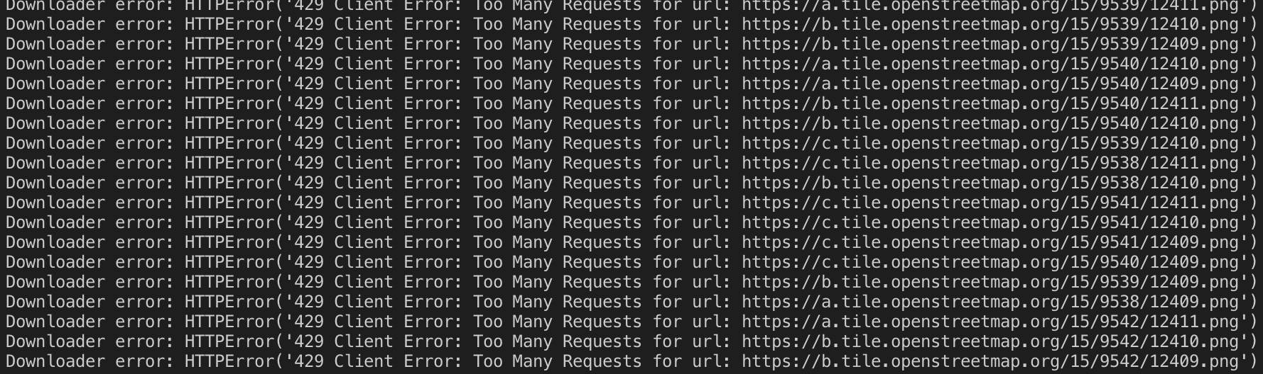

Solution: Check if you have cookies enabled your browser

# ***Information to contact the developer of the system if an undocumented question arises***

* You can reach the developers at:
  + Cameron Fritz: [cwf25@drexel.edu](mailto:cwf25@drexel.edu)
  + Ibrahim Elsaid: [ibe23@drexel.edu](mailto:ibe23@drexel.edu)
  + Jashanpreet Singh: [js4683@drexel.edu](mailto:js4683@drexel.edu)